**MAT 442: HMW 4**

1. Example 3 on page 7, we check the stability of the 2 cycle for the**Ricker model**: For *a* = 9 , *b* = 5 and

*yk*+1 = *aykebyk, a >* 1

* 1. we compute positive equilibrium point and check the stability

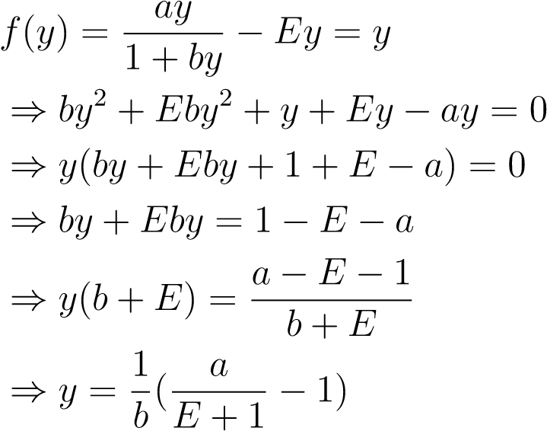

thus

*.*

*y*

∞

=(

*a*

*E*

+1

−

1)

*/b*

Now we find the derivative and substitute *y*∞,we have

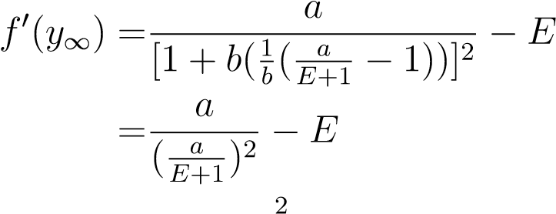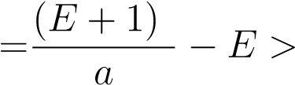0(we assume *E >* 0)*.*

For the nonzero equilibrium to be LAS, we want

on RHS will give us

−

1

*<*

(

*E*

+1)

2

*a*

−

*E<*

1

⇔

*E*

−

1

*<*

(

*E*

+1)

2

*a*

*<*

*E*

+1

⇔

*E*

−

1

*E*

+1

*<*

*E*

+1

*a*

*<*

1

,

theRHSoftheinequalityissatisfiedbecausealgebraicmanipulation

*E*

+1

*a*

*<*

1

⇔

*E<a*

−

1

hence

*E < A*

−

1

is satis

-

*E*

−

1

*E*

+1

*<*

*E*

+1

*a*

⇔

*a<*

(

*E*

+1)

2

*E*

−

1

fied.For LHS of the inequality we have

which automatically satisfies the condition because if *E <* 1 then 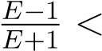0 so either one gives us LAS for the positive equilibrium.

* 1. In this part we derive the opposite conclusion to part(b) whenthe parameters do not give rise to LAS condition. For the first part we check what happens(behavior) using cobweb graph(Figure 1) when

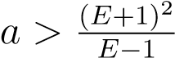.

For the second part we check what happens when *a < E* − 1 .It is obvious there is a contradiction because in part (a) above it was established that zero equilibrium is LAS when *E* − 1 *< a < E* + 1.There is zero equilibrium which is unstable hence population move towards extinction.

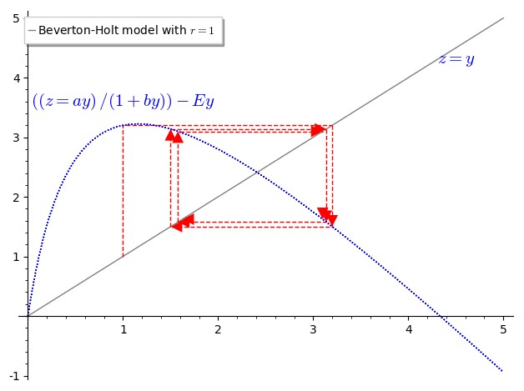

Figure 1: The cobweb diagram shows an oscillating movement around the equilibrium this means it is not approaching zero or extinction.

1. Comparing the existence and stability of equilibrium points, as well asthe general characteristics of solutions of Beverton-Holt model.

# (a) no harvesting

The equilibrium points are *y*∞1 = 0 if *a <* 1(make it is stable) and 1(makes it unstable).

# (b) constant-rate harvesting

The equilibrium points are

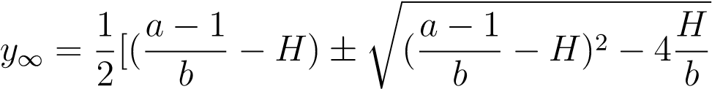

.

# (c) constant-effort harvesting

The equilibrium points are *y* = 0 and.For the nonzero

equilibrium to be LAS, we want

−1 *<* (*E*+1)*a* 2−*E <* 1 ⇔ *E*−1 *<* (*E*+1)*a* 2 *< E*+1 ⇔ *.*

*E*

−

1

*E*

+1

*<*

*E*

+1

*a*

*<*

1

**Conclusion:** In **no harvesting** which has two outcomes either *y* = 0 if *a <* 1 for stability where there is no need to introduce harvesting because fish population will move towards extinction or zero equilibrium.The other case for **no harvesting** is unstable if *a >* 1 which is pretty useful because there is excessive(rapid) growth of fish population.For **constant-rate harvest** it was established that to promote better modeling techniques for fish population can withstand harvesting without the fish population going to extinction and for what rate of harvesting will there be a positive asymptotically stable equilibrium.In **constant-effort harvesting** there is an exerted Effort ”E” and constant yield *Ey*.Since Beverton Holt model is a typical example for contest competition, some effects of harvesting in contest competition can lead to extinction of species and also harvesting occurring in finite time space.When harvesting is introduced to Beverton model it can lead to jump in equilibrium called catastrophe, meaning the fish population will be wipe out as a result of harvesting rate *H* increasing beyond certain value of threshold where there is no equilibrium.(Figure 2.21-2.23 on p.63 of our textbook give a clear graph of the qualitative behavior).

3. Section 2.5 Exercise 10 (p.68). Logistic model with constant-effort harvesting. (a)

*f*

(

*y*

)=

*ry*

(1

−

*y*

*k*

)

−

*Ey.*

To find equilibrium points, set

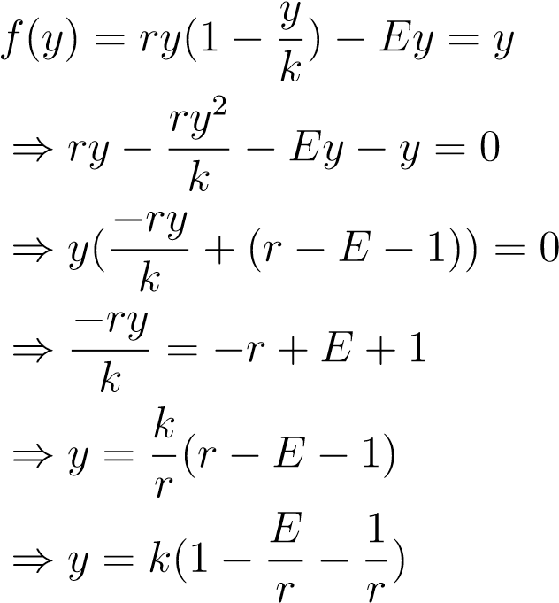

1. we have the equilibrium points to be

*y*

1

∞

= 0

and

*y*

2

∞

=

*k*

(1

−

*E*

*r*

−

1

*r*

)

*.*

Now for all the non negative equilibrium points, with conditions on the parameters for the positive equilibrium we want

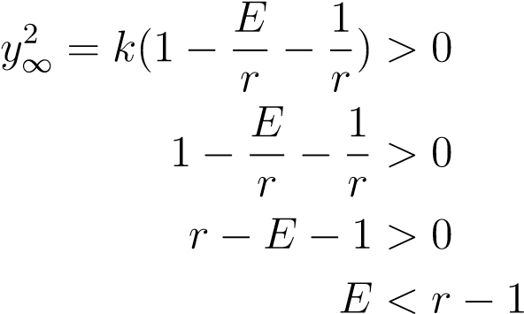*.*

1. To study the stability of nonnegative equilibria analytically we findthe derivative of *f* ,substitute *y*∞1 and *y*∞2 to obtain

*f*0(*y*) = *r* − *y* − 2*y* − *E* ⇒ *f*0(*y*∞1 = 0) = *r* − *E .*

For the stability of zero equilibrium: We set

−1 *< r* − *E <* 1 ⇔ *r* − 1 *< E < r* + 1

For the stability of positive equilibrium: we have

0 2 2*r E* 1 *f* (*y*∞) = *r*− (*k*(1− − )−*E* = *r*−2*r*+2*E*+2−*E* = *E* − *r* + 2 *. k r r*

For the equilibrium to be LAS, we need

−1 *< E* − *r* + 2 *<* 1 ⇔ −3 *< E* − *r* − 1 ⇔ *r* − 3 *< E < r* − 1*.*

4. Comparing the existence and stability of equilibrium points, as well as the general characteristics of solutions of Logistic model.

# (a) no harvesting

The equilibrium points are *y*∞ = 0 and ), as per our LN

3 we established that |*f*0(0)| = *r >* 1,so that 0 is always unstable and

|2 − *r*| *<* 1 ⇔ −1 *< r* − 2 *<* 1 ⇔ 1 *< r <* 3*.*

# (b) constant-rate harvesting

The equilibrium points are

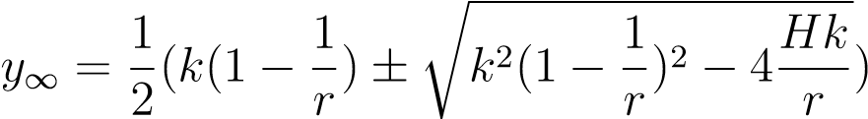

,from our LN5 we know that

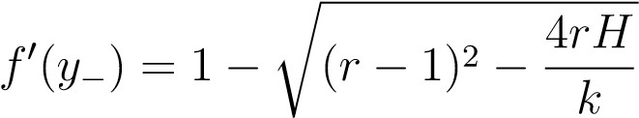

therefore, there is an existence of stability.

# (c) constant-effort harvesting

The equilibrium points are ).For the stability of zero equilibrium we set −1 *< r* − *E <* 1 ⇔ *r* − 1 *< E < r* + 1 and for stability of positive for the LAS we need, −1 *< E* − *r* + 2 *<*

1 ⇔ *r* − 3 *< E < r* − 1.

**Conclusion:** In **no harvesting** for logistic model with *r >>* 1 there will be no asymptotically stable equilibrium.For **constant-rate harvesting** in logistic model there is upper bound interval(*Hmax*) and lower bound interval(*Hmin*) when *r >* 3 we can derive means of stability by regulating the population through harvesting this avoids fluctuations in the fish population and keeps it steady.From the previous Homework we know that scramble competition with discrete logistic growth model and fertility growth rate *r >>* 3 has no LAS positive equilibrium meaning there is higher movement in chaotic manner so introducing harvesting into this population will regulate the population rise, keep it in a steady manner so there will be enough resources for fish to also feed on.When *Ey* thus **constant-effort harvesting** is applied to the discrete model there will be more fish to catch because default logistic model with no harvesting has high fertility growth rate *r >>* 3 in scramble competition.

# References

[1] Dynamical Systems for Biological Modeling: An Introduction by Brauer and Kribs, CRC Press, 2016. ISBN 978-1-4200-6641-8